**LISTEN AND COMPLETE THE LYRICS.**

If I **1) _______**a boy  
Even just for a day  
I **2) _______** roll outta bed in the morning  
And throw on what I wanted and go  
Drink beer with the guys  
And chase after girls  
I’d kick it with who I wanted  
And I’d never get confronted for it.  
'Cause they’d stick up for me.  
  
If I were a boy  
I think I **3) _______** understand  
How it feels to love a girl  
I swear I’d be a better man.  
I **4) _______** to her  
'Cause I know how it hurts  
When you lose the one you wanted  
'Cause he’s taken you for granted  
And everything you had got destroyed  
  
If I were a boy  
I **5) _______** my phone  
Tell everyone it’s broken  
So they’d think that I was sleepin’ alone  
I **6) _______** myself first  
And make the rules as I go  
'Cause I know that she’d be faithful  
Waitin’ for me to come home (to come home)  
  
If I were a boy  
I think I could understand  
How it feels to love a girl  
I swear I **7) _______** a better man.  
I’d listen to her  
'Cause I know how it hurts  
When you lose the one you wanted (wanted)  
'Cause he’s taken you for granted (granted)  
And everything you had got destroyed  
  
  
It’s a little too late for you to come back  
Say it's just a mistake  
Think I **8) _______**you like that  
If you thought I **9)** _______ for you  
You thought wrong  
  
  
But you’re just a boy  
You don’t understand  
Yeah, you don’t understand, oh  
How it feels to love a girl someday  
You wish you **10) _______** man  
You don’t listen to her  
You don’t care how it hurts  
Until you lose the one you wanted  
'Cause you’ve taken her for granted  
And everything you had got destroyed  
  
But you’re just a boy

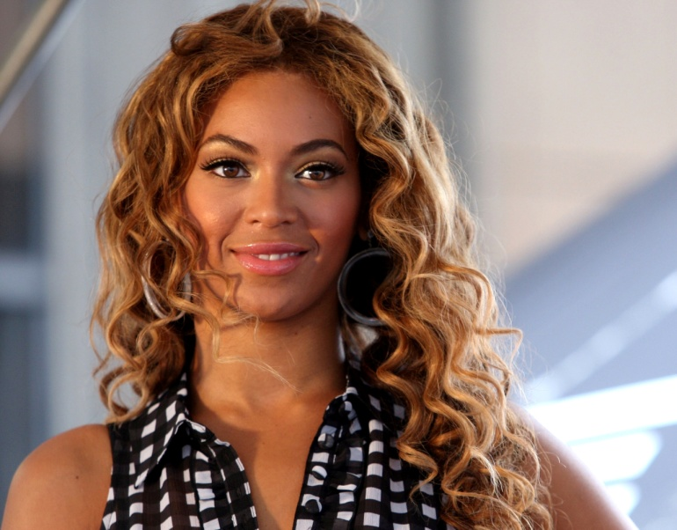

*Singer and actress Beyoncé Giselle Knowles was born on September 4, 1981, in Houston, Texas. She started singing at an early age, competing in local talent shows and winning many of these events by impressing audiences with her singing and dancing abilities.*